Introduction to Cloud Solutions Lab Report

Use this template to document your work as you complete the lab assignment in QA.

# Your Information

Your Name: Mahlon Sutton

Lab Title: Introduction to Azure Bicep Templates

# Instructions

Follow the instructions to answer the questions related to the lab and add the required screenshots. Submit your completed report following the instructions in Canvas.

## Section Logging into Azure using Azure CLI

1. **Step 3 Screenshot:** After executing the copied command in the CLI, take a screen shot of the   
results and add it to your lab assignment report

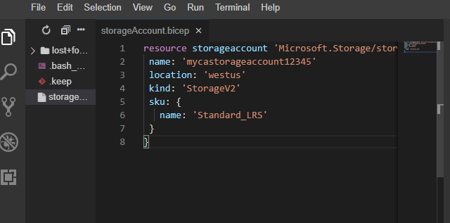

## Section Adding Resources to an Azure Bicep Template

2. **Step 4 Screenshot:** With all of the required changes made and after saving your template file,  
 take a screen shot of the template file and add it to your lab assignment report.

3. **Step 7 Screenshot:** Output results from running the Bicep template.

## Section Customizing an Azure Resource Manager Template

4. **Step 10 Screenshot:** Confirm web app has deployed successfully.

